Virginia State Association of Parliamentarians

61st ANNUAL CONVENTION

The Virginia State Association of Parliamentarians (VSAP) calls its members and friends to the 61ST Annual Convention. This is an opportunity for members to learn, enhance or update parliamentary procedure skills, receive support from other Units and Club, and establish, and renew relationships and acquaintances.

Saturday and Sunday,
May 5-6, 2018
Newport News Marriott at City Center
740 Town Center Drive
Newport News, Virginia 23606
1-(757) 873-9299
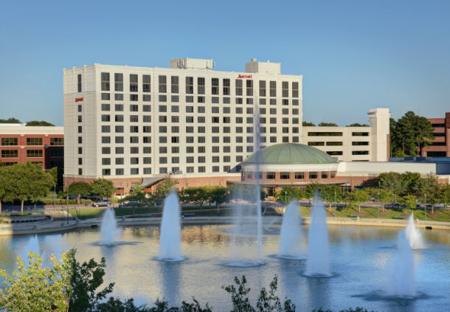

Newly Renovated: Luxury full service hotel with concierge lounge
Room Rate: $115.00 plus taxes
Double or Single

